DAD 220 Project One Template

Complete these steps as you work through the directions for Project One. Replace the bracketed text with your screenshots and brief explanations of the work they capture. Each screenshot and its explanation should be sized to approximately one-quarter of the page with the description written below the screenshot. Follow these rules for each of the prompts and questions below. Review the example document in the Supporting Materials section of the Project One Guidelines and Rubric for assistance.

Step One: Create a Database

- In your online IDE (Codio), create a database schema called QuantigrationUpdates that will hold tables by using SQL commands.
  - List out the database name on the screen.
  - Provide the SQL commands you ran against MySQL to complete this step.

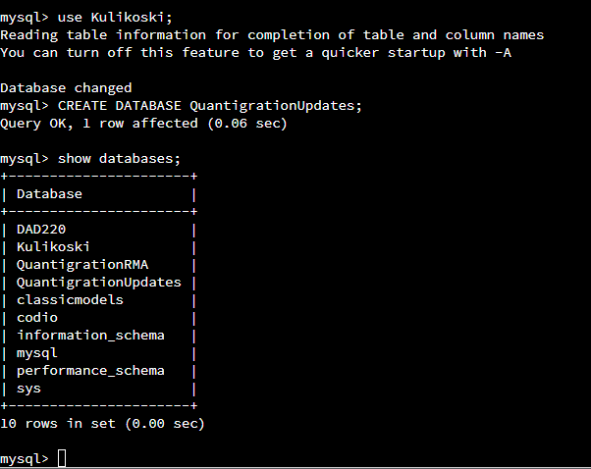

I first ran a command to use Kulikoski and then created a new database called QuantigrationUpdates. Then I ran a command to show all databases under Kulikoski.

- Connect to the QuantigrationUpdates schema. Using the ERD as a reference, write SQL commands to create the following tables with the appropriate attributes and keys to demonstrate relationships based on the ERD.
  - A table named Customers to store customer information with a primary key of Customer ID. Provide the SQL commands you ran against MySQL to complete this step.

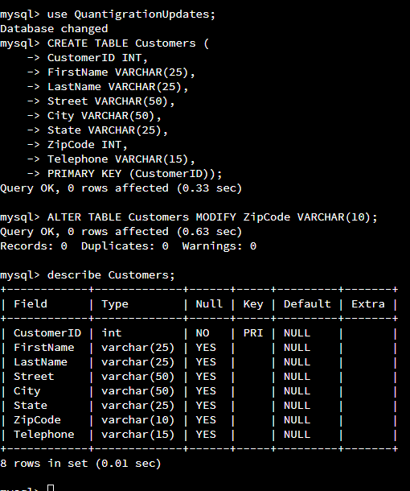
I created a table under QuantigrationUpdates called Customers and followed the characteristics of the RMA ERD. I put INT in the zip code originally but modified it to VARCHAR(10).
  - A table named Orders to store order information with a primary key of Order ID and a foreign key of Customer ID. Provide the SQL commands you ran against MySQL to complete this step.

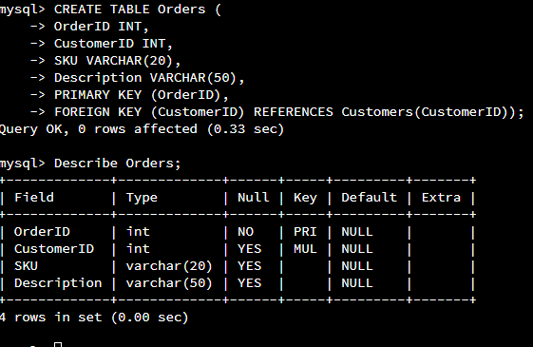
I created a table called Orders with the characteristics from the RMA ERD charts. I made OrderID the primary key and the foreign key is CustomerID linked to CustomerID in the Customers table.
  - A table named RMA to store RMA information with a primary key of RMA ID and a foreign key of Order ID. Provide the SQL commands you ran against MySQL to complete this step.

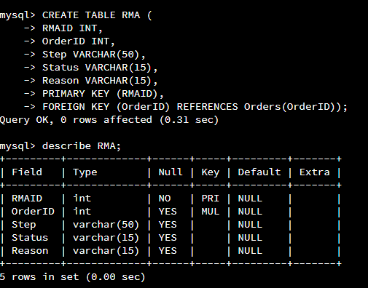
I created a new table named RMA based on the RMA ERD charts. I made the RMAID the primary key and OrderID the foreign key linked to the Orders table.

Step Two: Load and Query the Data

- Import the data from each file into tables.
  - Use the QuantigrationUpdates database, the three tables you created, and the three CSV files preloaded into Codio.
  - Use the import utility of your database program to load the data from each file into the table of the same name. Perform this step three times, once for each table.
  - Provide the SQL commands you ran against MySQL to complete this step.

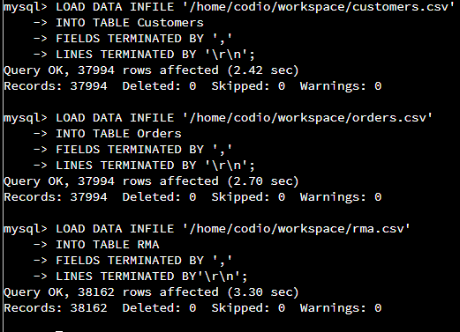

I ran commands to load in the data from the preloaded CSV files on codio into the tables that they were named for.

- Write basic queries against the imported tables to organize and analyze the targeted data. For each query, replace the bracketed text with a screenshot of the query and its output. Also, include a one- to three-sentence description of the output.
  - Write a SQL query that returns the count of orders for customers located only in Framingham, Massachusetts.
    - This query will use a table join between the Customers and Orders tables. The query will also use a WHERE clause.
    - How many records were returned?
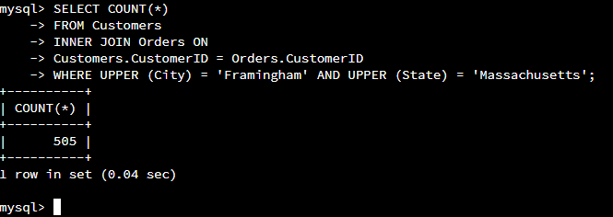
I ran a query for Codio to count all the customers that are from Framingham, Massachusetts. I joined the tables Customers and Orders based on the shared key of CustomerID and used WHERE for it to only show results from Framingham, Massachusetts. The query resulted in 505 customers.

  - Write a SQL query to select all of the customers located in Massachusetts.
    - Use a WHERE clause to limit the number of records in the Customers table to only those who are located in Massachusetts.
    - How many records were returned?

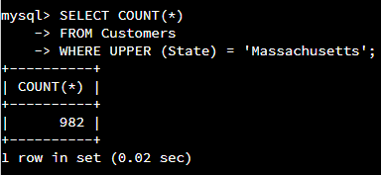
I ran another query to count the customers from all of Massachusetts, but only from the customers’ table. The search resulted in a count of 982 customers.
  - Write a SQL query to insert four new records into the Orders and Customers tables using the data below:

Customers Table
CustomerID | FirstName | LastName | StreetAddress | City | State | ZipCode | Telephone
100004 | Luke | Skywalker | 15 Maiden Lane | New York | NY | 10222 | 212-555-1234
100005 | Winston | Smith | 123 Sycamore Street | Greensboro | NC | 27401 | 919-555-6623
100006 | MaryAnne | Jenkins | 1 Coconut Way | Jupiter | FL | 33458 | 321-555-8907
100007 | Janet | Williams | 55 Redondo Beach Blvd | Torrence | CA | 90501 | 310-555-5678

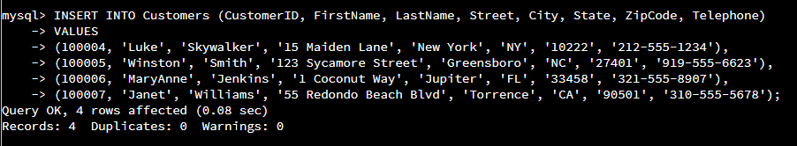

I wrote a query to add the four names above into the customers’ table. I had to describe the table in the query as well as add all the info for each person.
Orders Table
OrderID | CustomerID | SKU | Description
1204305 | 100004 | ADV-24-10C | Advanced Switch 10GigE Copper 24 port
1204306 | 100005 | ADV-48-10F | Advanced Switch 10 GigE Copper/Fiber 44 port copper 4 port fiber
1204307 | 100006 | ENT-24-10F | Enterprise Switch 10GigE SFP+ 24 Port
1204308 | 100007 | ENT-48-10F | Enterprise Switch 10GigE SFP+ 48 port

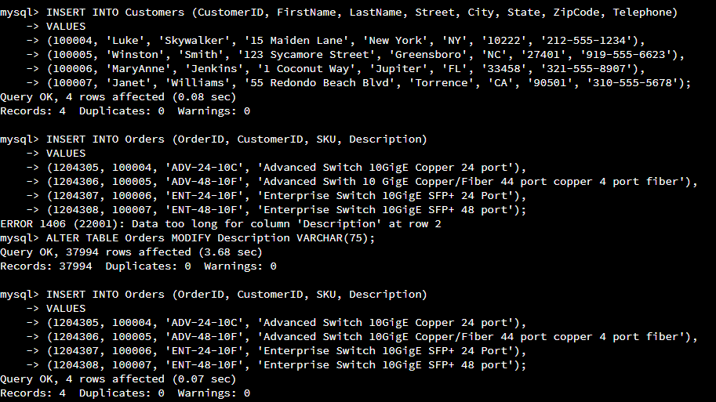
I also wrote a query to insert the data from the table above into the Orders table. This first one I ran resulted in and error for the Description column so I altered the table to include more characters. I was successful on my second try after altering the table.

  - In the Customers table, perform a query to count all records where the city is Woonsocket and the state is Rhode Island.
    - How many records are in the Customers table where the field "city" equals "Woonsocket"?

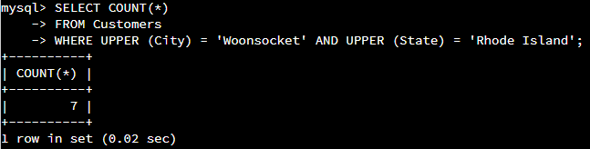
There are a total number of 7 records for customers in Woonsocket, Rhode Island.

  - In the RMA database, update a customer's records.
    - Write a SQL statement to select the current fields of status and step for the record in the RMA table with an OrderID value of "5175".
      - What are the current status and step?

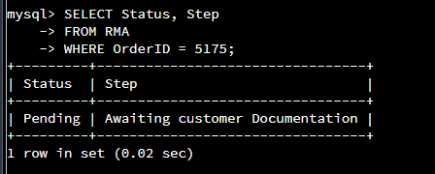
The order with the ID of 5175 is currently still pending and waiting for customer documentation.

    - Write a SQL statement to update the status and step for the OrderID, 5175 to status = "Complete" and step = "Credit Customer Account".
      - What are the updated status and step values for this record?

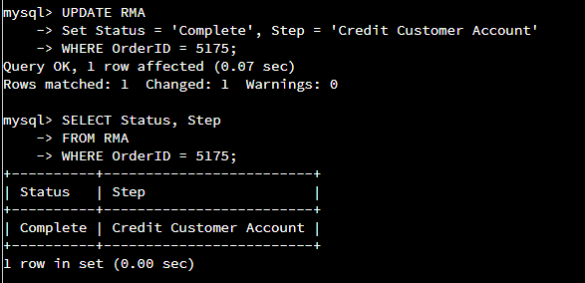
After updating the RMA table, the order for ID 5175 is currently completed and that the customer account is to be credited.

  - Delete RMA records.
    - Write a SQL statement to delete all records with a reason of "Rejected".
      - How many records were deleted?

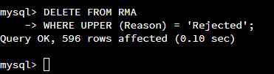
Running a query to delete all records that were rejected resulted in removing 596 records from the RMA table.

- Update your existing tables from "Customer" to "Collaborator" using SQL based on this change in requirements. Copy and paste the SQL you write to do the following action:
  - Rename all instances of "Customer" to "Collaborator".

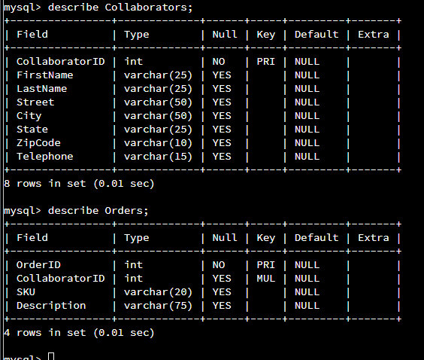
I renamed the Customers table to Collaborators. Then, I altered Collaborators and Orders table to change CustomerID into CollaboratorID.

- Create an output file of the required query results. Write a SQL statement to list the contents of the Orders table and send the output to a file that has a CSV extension.

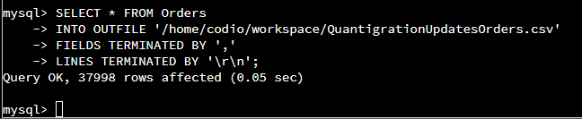

I wrote a statement to take the Orders table and put the data into an outfile saved under “QuantigrationUpdatesOrder.csv”.

